|  |  |  |  |  |  |
| --- | --- | --- | --- | --- | --- |
| Date | 24-Nov-22 | | | Tester Name | Shahabuddin Syed |
| Environment | Penfax - Test | | | Login used |  |
| Operating System | Windows | Version: | Update: | | |
| Software Used | Edge | Version: | Update: | | |
| Not Applicable | Version: | Update: | | |
| Release version | 22.4.1 | | | | |
| Title | M11.07 – Project Estimates | | | | |
| Test Type | Regression | | | | |
| Test Scenario | Vested casual married member eligible for unreduced pension with different service types has eligibility service > 20 years | | | | |
|  |  | | | | |
| Expected Results |  | | | | |
| Pass/Fail | Pass | | | JIRA# | N/A |

Describe your steps with screenshots:

Login into Penfax application

Search for the member

Click on their stakeholder ID - 115391

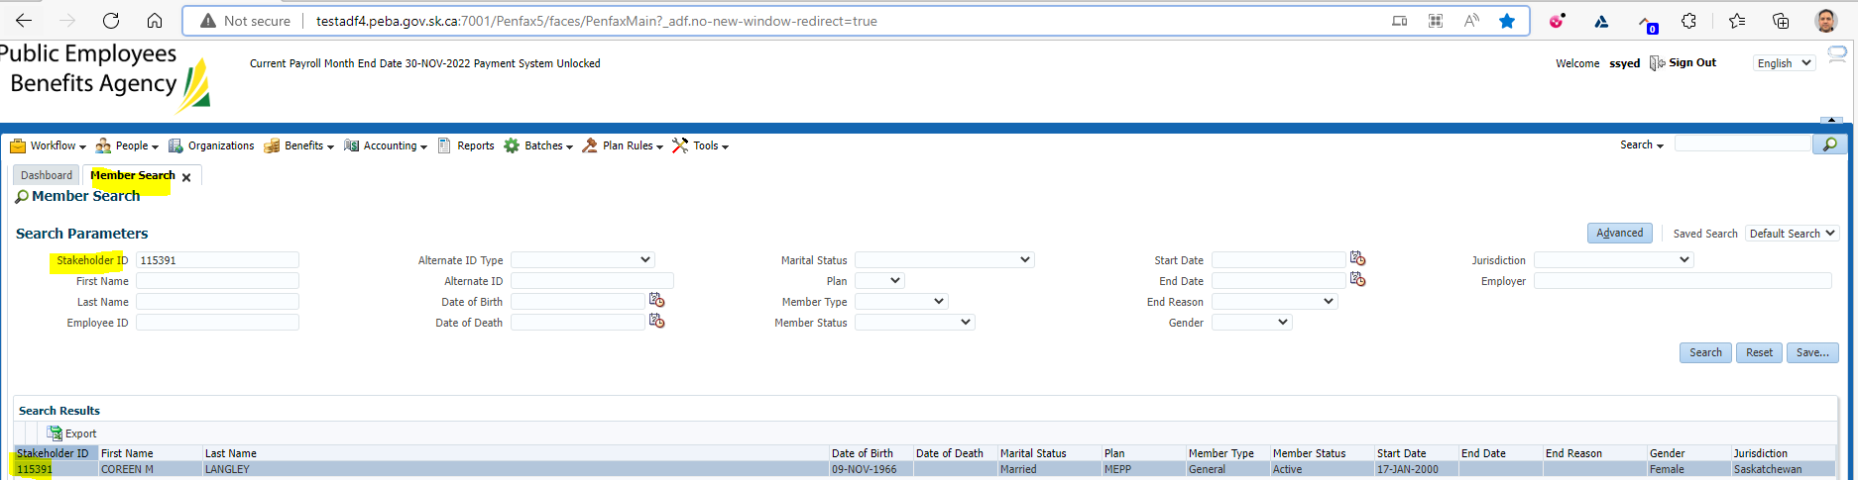

Click on Retirement Projection tab

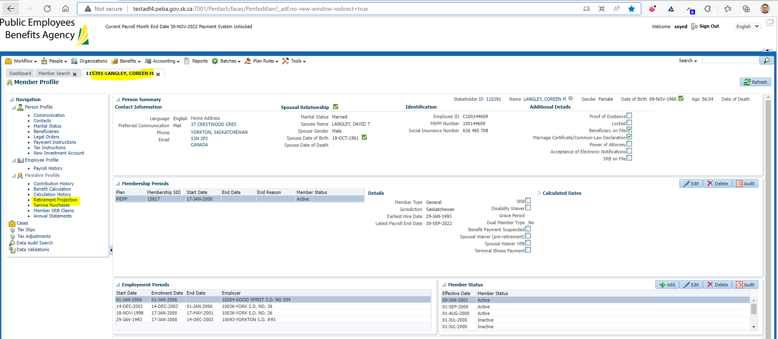

Click on Calculate Retirement Dates

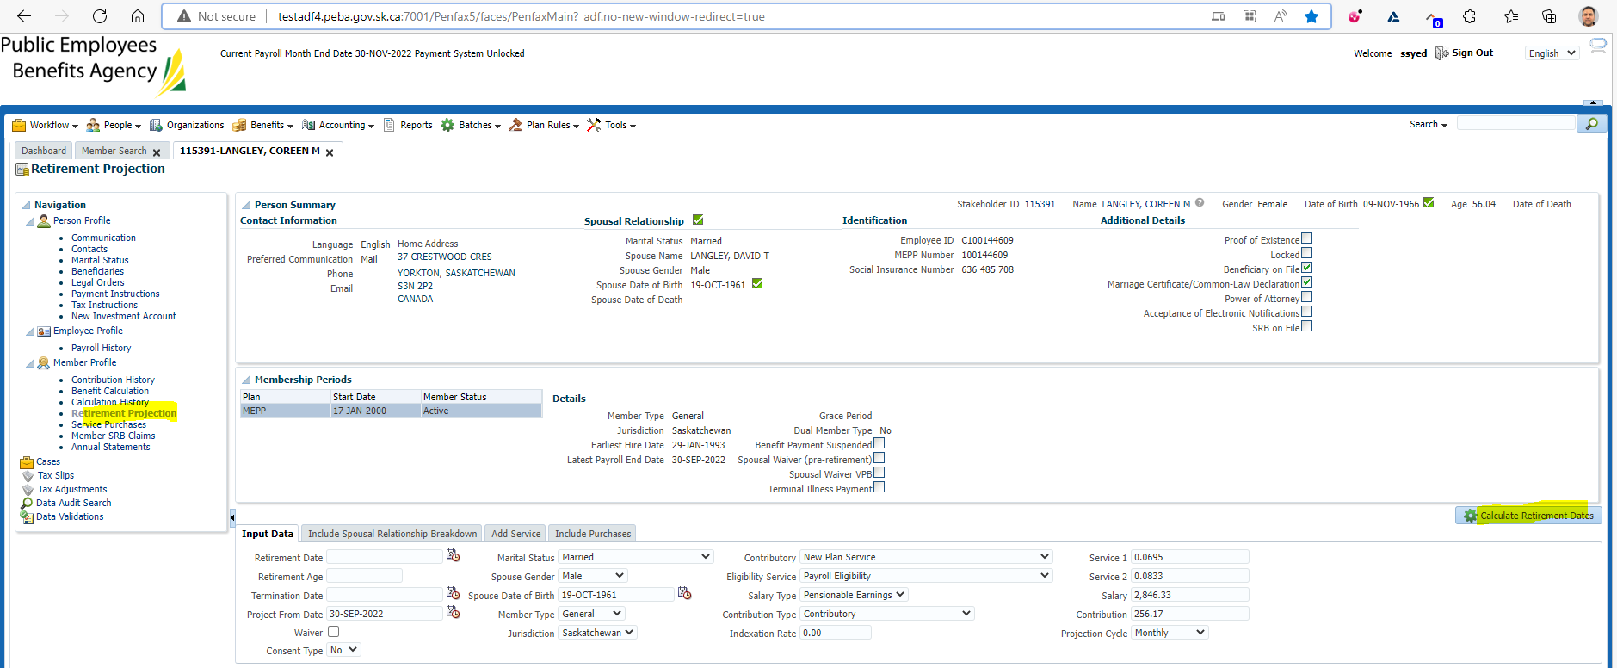

Click on Calculate Retirement Dates

New tab under Retirement Dates gets opened

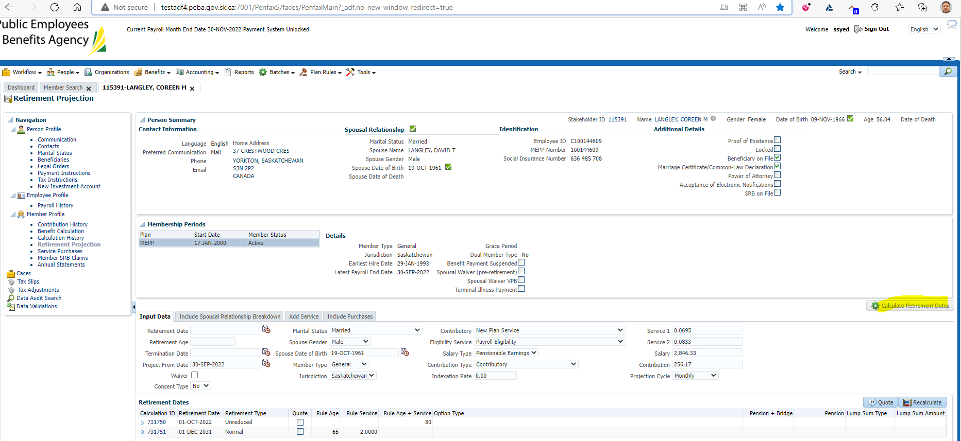

Click on Quote

Make sure it has been tick marked on the Quote button under Retirement Dates

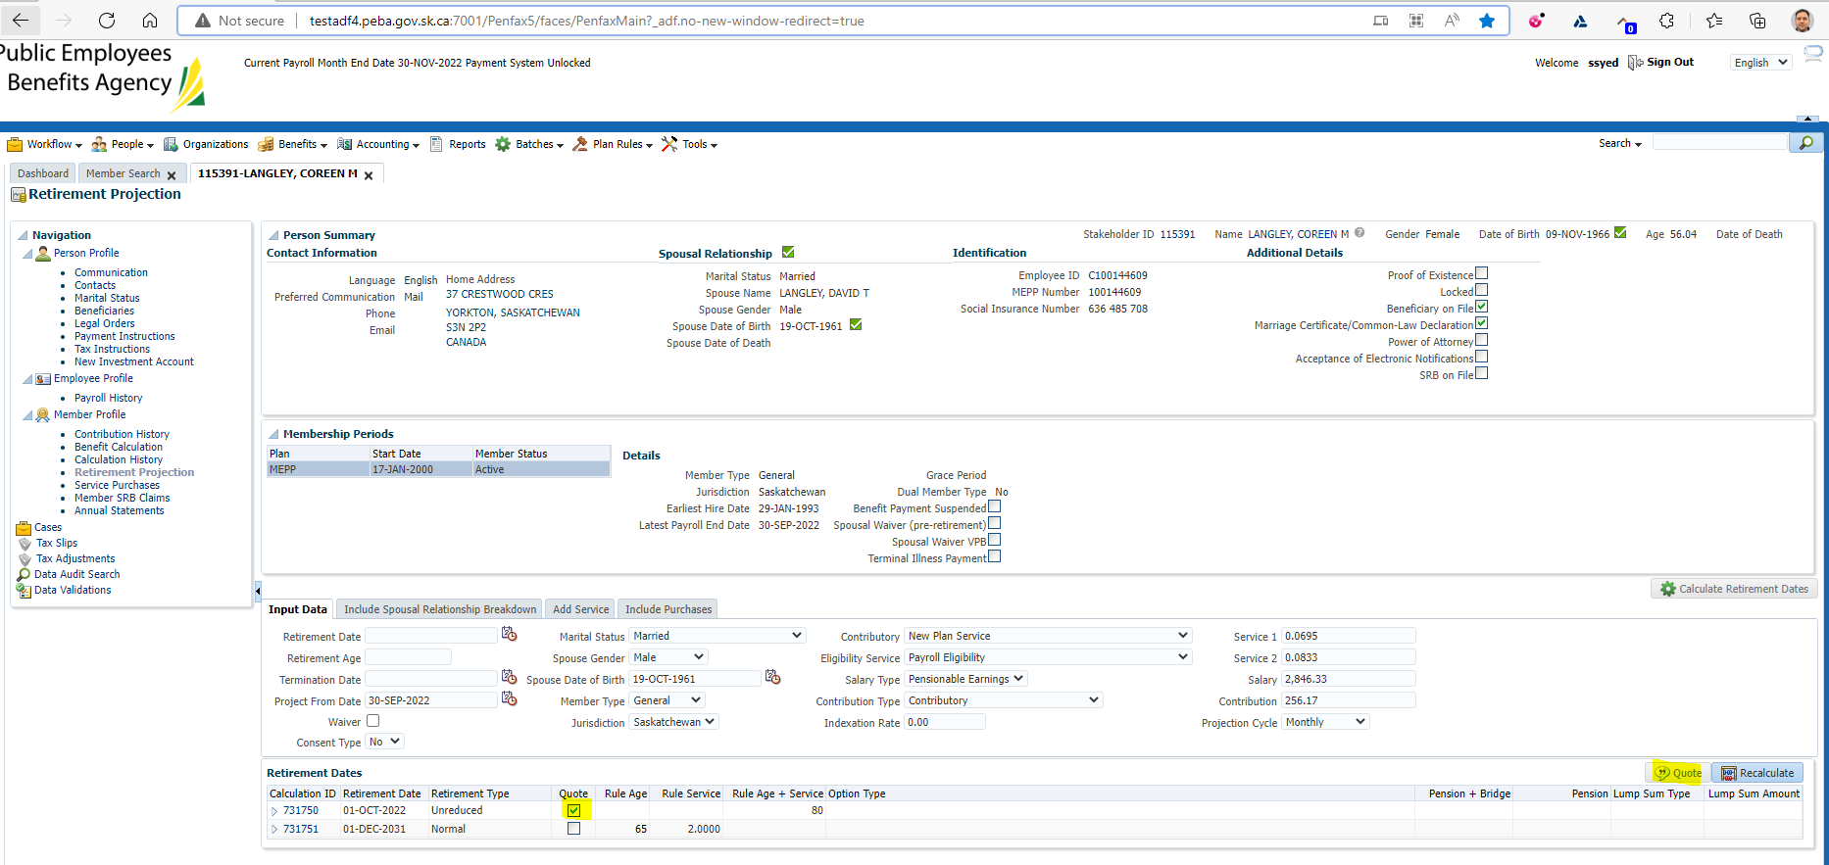

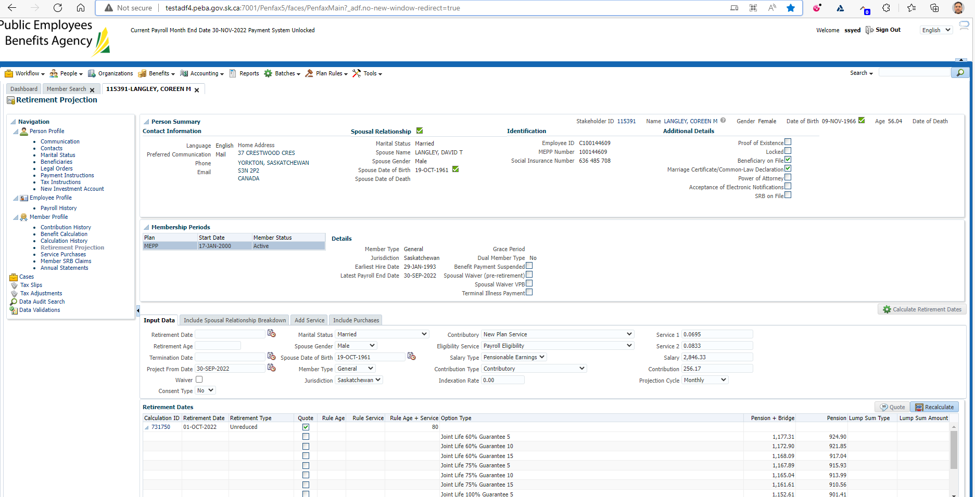

Comparison with Test1 Region:

Login into Penfax application

Search for the member

Click on their stakeholder ID

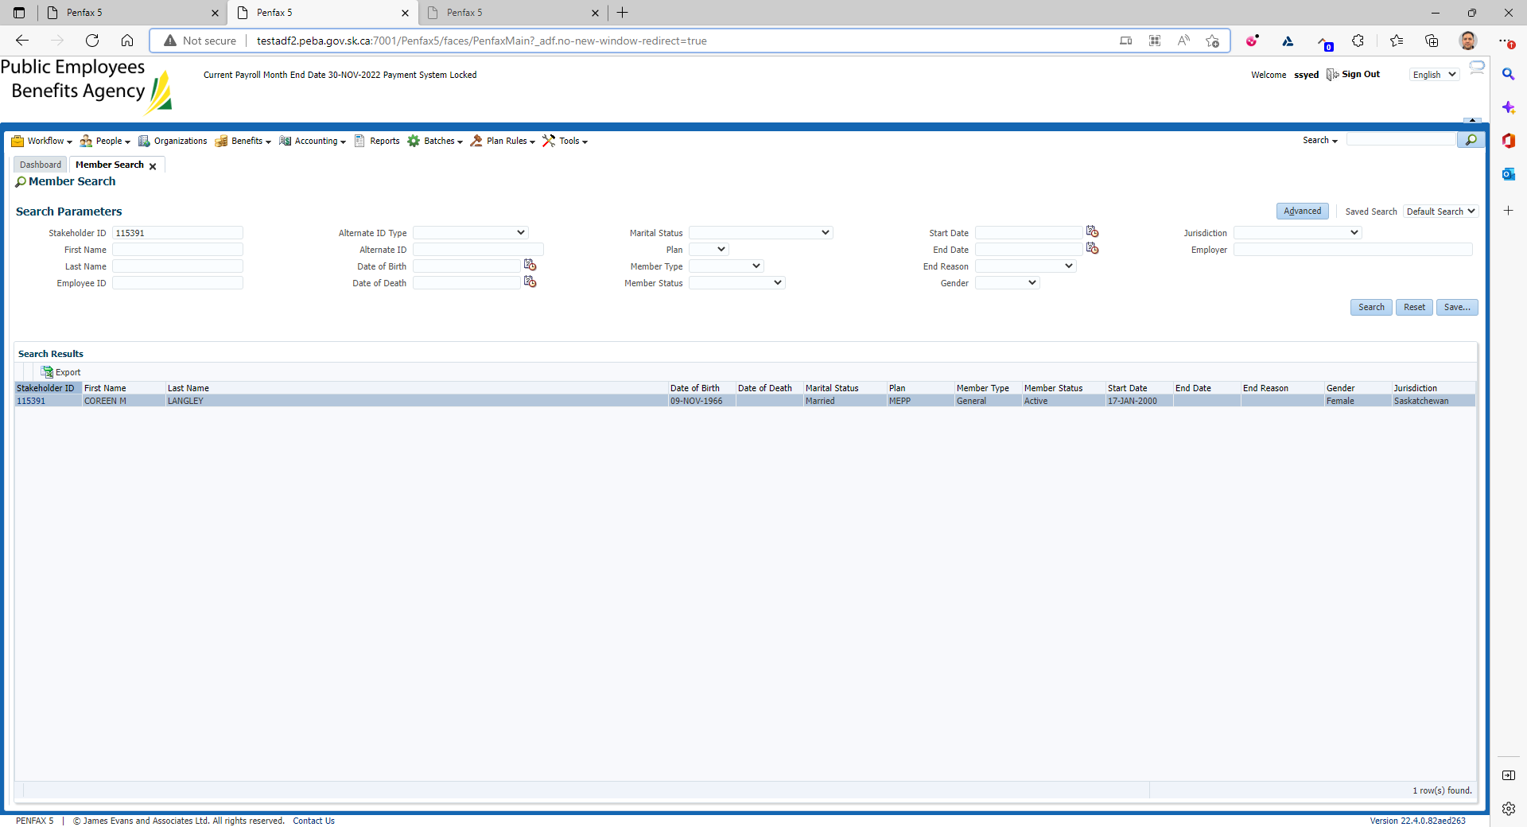

Click on Retirement Projection tab

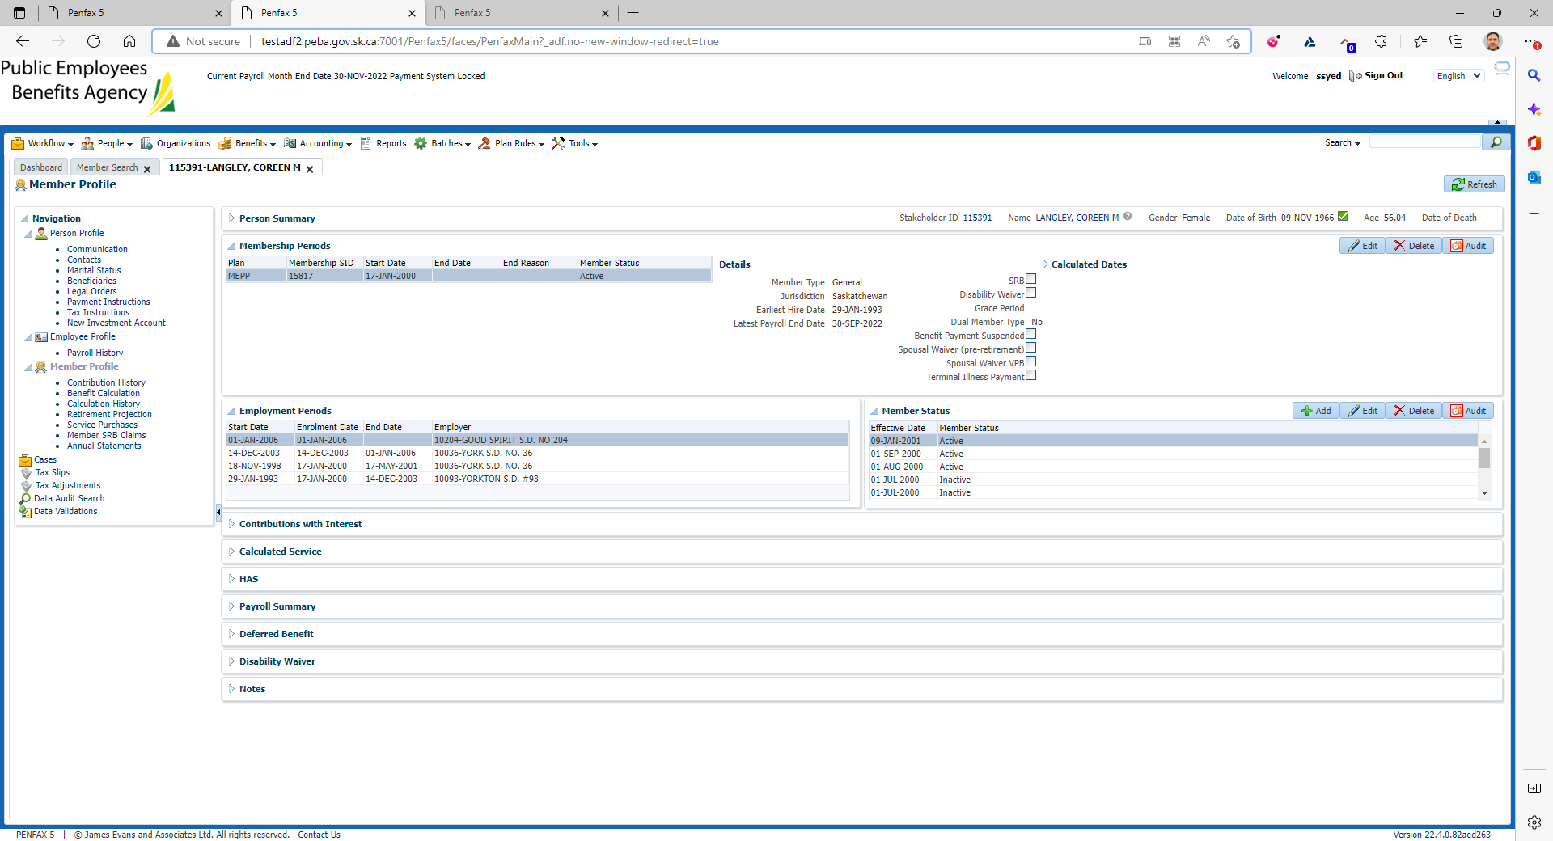

Click on Calculate Retirement Dates

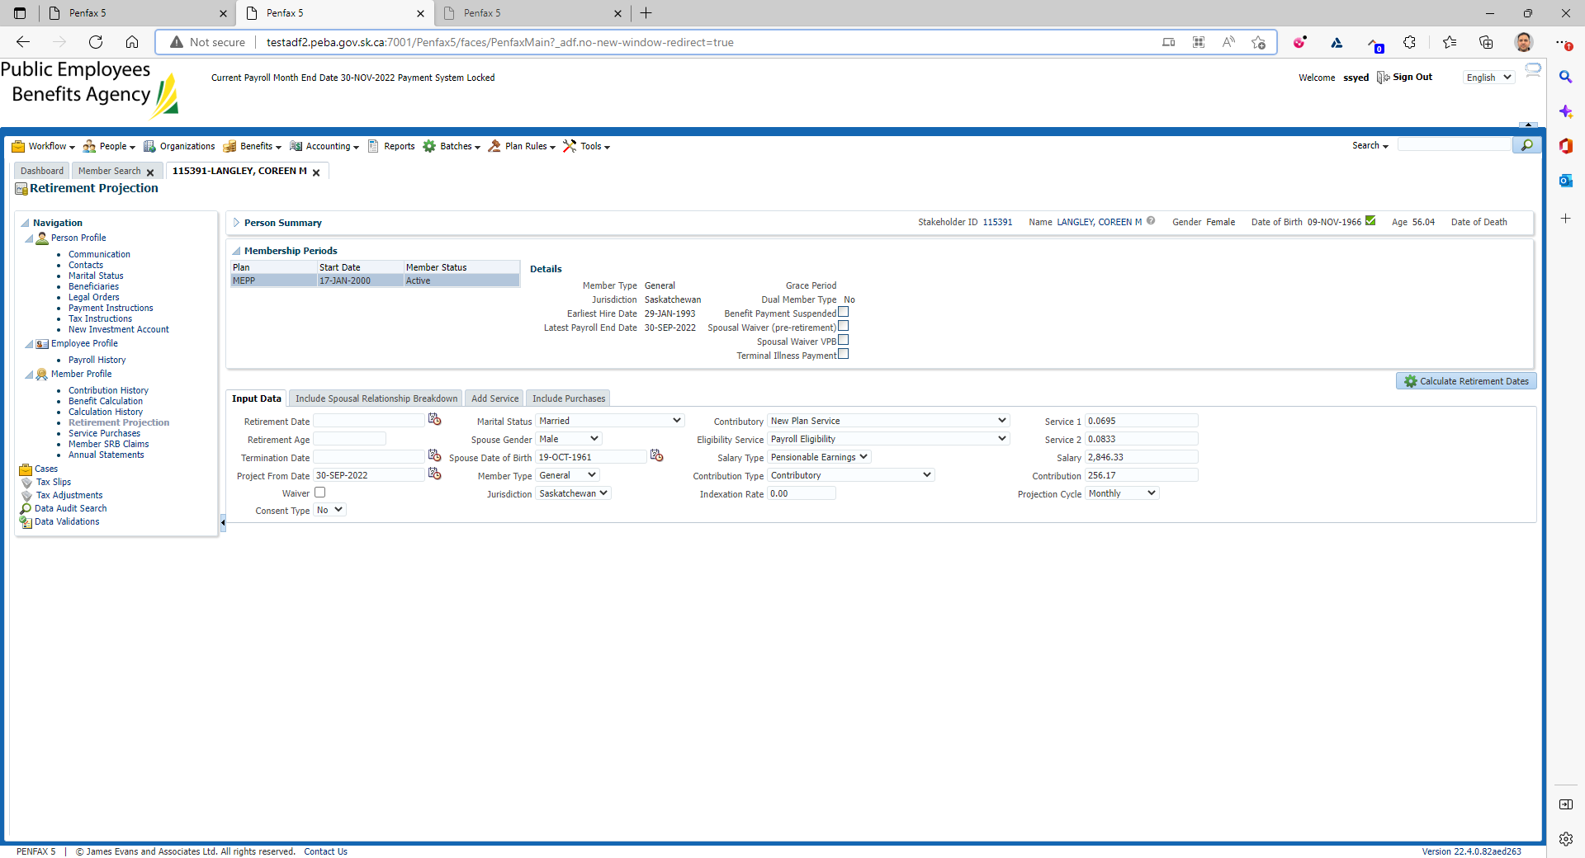

Click on Calculate Retirement Dates

New tab under Retirement Dates gets opened

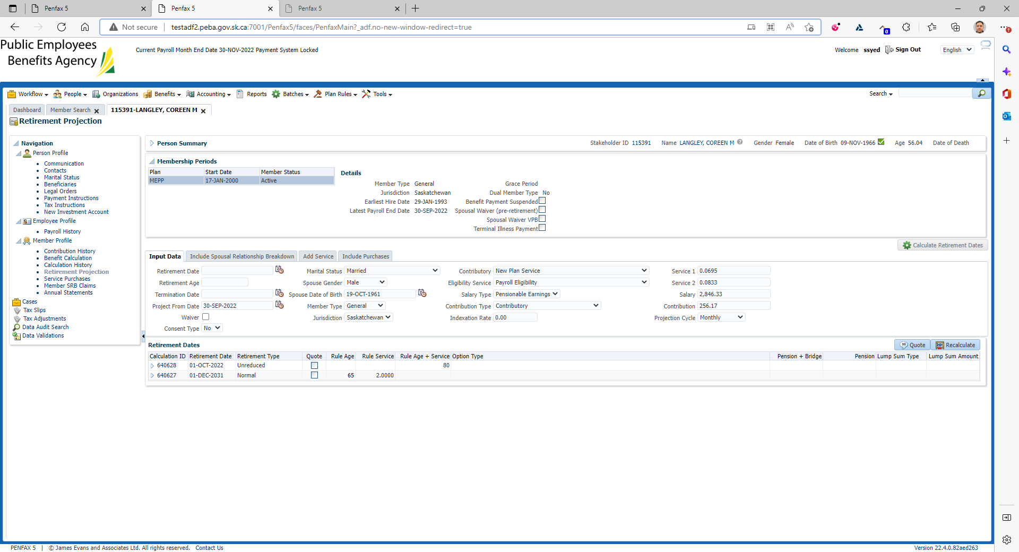

Click on Quote

Make sure it has been tick marked on the Quote button under Retirement Dates

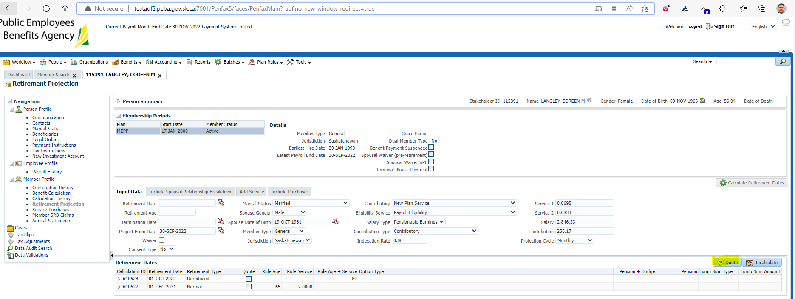

Comparison between Test1 & Test2

